**Pair Programming - 3**

1. Given the output

First  
Second  
Third

Using a single string, show the println() statement that created this.

1. Write a program to convert miles to kilometers
   1. Make sure you “desk check” to ensure it’s producing the correct output.
   2. It should be able to handle fractional miles (e.g. 1.6 miles as an input value).
   3. Output should be a decimal and a well formatted message, something like

*2 miles equals 3.21869 Kilometers*

* 1. Challenge: Have your main method in a separate class

1. Wouldn’t it be nice if we didn’t have to hard code the input values? Modify your program to take in a value representing the number of miles from the console.
   1. Research the Scanner class – you will need to add an import statement before your class statement.

*import java.util.Scanner;*

* 1. Remember, your mentor is available if you need help.

1. Change your answer to only print out 2 decimal places. (hint: research “printf”)

<Optional if time allows>

1. How about a Graphical User Interface (GUI)? Research JOptionPane and create something similar to this that takes the input in miles then when the user clicks “OK” it prints the result to the command line.

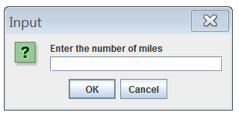

1. Is your program grammatically correct? i.e. If a user enters 1 does it say “*1 miles equals…” or “1 mile equals …”*  Ensure that your output can handle the following input as test data: 0, 0.3, 1, 5
2. SHOW OFF TIME – Try one of these:
   1. Enhance the program above to either do something that you want to practice more (e.g. add another method for converting kilometers back to miles, use increment/decrement operators).
   2. Enhance the program to do something we have NOT done in class. Either based on your previous programming knowledge or an idea you just want to research.